Recommended Poster Size
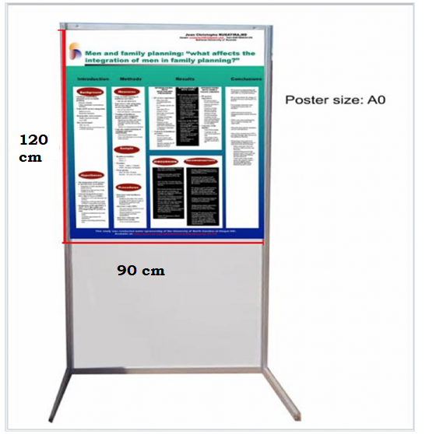
90 cm width × 120 cm height

Important things to Know
  - All posters should be prepared in advance and brought to the conference by the presenters. The conference organizers are NOT able to receive any posters by mail in advance, print or transport posters.
  - There will NOT be facilities on-site for printing or composing posters.
  - No audiovisual equipment is permitted for poster presentations.
  - Each poster should be no larger than A0 paper size measuring 90 cm width × 120 cm height

Poster Design Guidelines
Poster Dimensions:
The maximum poster dimensions allowed are: 90 cm x 120 cm (portrait orientation). In order to fit the poster board, your poster should not exceed the recommended size. The organizers will provide suitable fixing materials and on-site assistance will be available to help you display your poster.
The organizers are not responsible for loss or damage to any posters that are not removed by authors within the times of dismantling. Posters left behind will be automatically destroyed.

Header
Prepare a headline that is reflective of the research, program or intervention. Include the authors and their affiliations (institution/organization) under the header for identification.
Organization
The objective is to present the information clearly and simply in a visually appealing way. Be careful not to overload the poster with text and/or graphics. Please use a consistent style and sequence (left to right or top to bottom) to guide the viewer through the poster. You may use figures, tables, graphs and/or photographs where suitable. Keep the text brief and to the point.
Layout
Posters should include appropriately labeled illustrative graphs and diagrams as much as possible. Long textual passages should be avoided, and the methodology section generally should be brief unless it is the main focus of the abstract. Use a large font size for your text, such as 24-point and arrange materials in columns rather than in rows to make your poster more reader-friendly. Indicate the sequence of tables, figures or graphs with highlighted or colored numbers or letters at least one inch high.
Typography
Avoid using abbreviations, acronyms and/or jargon in your poster. Make sure the font is consistent throughout.
Printing
Most print shops offer several options for printing posters. There are no requirements for type of printing as long as it is no larger than A0 paper size 90 cm width × 120 cm height
.
Your poster may include these elements:
- Introduction or objective
- Methods
- Results
- Conclusions and/or discussion
- Acknowledgements

